
UNIT 3ACHE

RATES & EQUILIBRIUM

NAME: TIME ALLOWED: 60 MINUTES

Section One: Multiple Choice Questions. (10 marks)

1. The addition of a catalyst to a chemical reaction

A. lowers the activation energy required for the reaction to occur.
B. lowers the chemical energy of the products.
C. lowers the chemical energy of the reactants.
D. lowers the value of the enthalpy change for the reaction.

2. The change in energy during a reaction is represented in the following energy profile diagram.
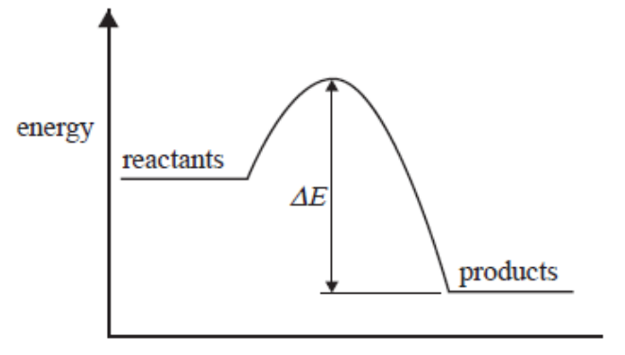
The change in energy labelled ΔE above is

A. the energy absorbed when bonds in the reactants break.
B. the activation energy of the forward reaction.
C. the activation energy for the reverse reaction.
D. the heat of reaction.

3. If, for the reaction

C₂H₅OH_{(g)} + 3O_{2(g)} → 2CO_{2(g)} + 3H₂O_{(l)} ; ΔH = −1364 kJ mol^{–1}

then the ΔH value for 4CO_{2(g)} + 6H₂O _{(l)} → 2C₂H₅OH_{(g)} + 6O_{2(g)} would be

A. +2728 kJ
B. +1364 kJ
C. +682 kJ
D. –1364 kJ
4. Consider the following equilibrium

2ClF_{3(g)} 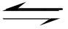 3F_{2(g)} + Cl_{2(g)} ; ΔH = − ve

For a particular equilibrium mixture, the temperature is lowered and the amount of ClF₃ changes by 0.010 mol.

The changes occurring would be

 | ClF₃ | F₂ | Cl₂
A. | Increase by 0.010 mol | Decrease by 0.015 mol | Decrease by 0.0050 mol
B. | Increase by 0.010 mol | Decrease by 0.0067 mol | Decrease by 0.020 mol
C. | Decrease by 0.010 mol | Increase by 0.015 mol | Increase by 0.0050 mol
D. | Decrease by 0.010 mol | Increase by 0.067 mol | Increase by 0.020 mol

5. The concentrations of reactants and products were studied for the following reaction.

H_{2(g)} + F_{2(g)} 2HF_{(g)} ; K = 313 at 25°C

In an experiment, the initial concentrations of the gases were
[H₂] = 0.0200 M, [F₂] = 0.0100 M and [HF] = 0.400 M

When the reaction reaches equilibrium at 25°C, the concentration of HF will be

A. 0.400 M
B. 0.420 M
C. between 0.400 M and 0.420 M
D. less than 0.400 M

6. The anaesthetic, nitrous oxide, N₂O, decomposes to form an equilibrium mixture of N₂O, N₂ and O₂ according to the following equation.

2N₂O_{(g)} 2N_{2(g)} + O_{2(g)}

At 25°C, K = 7.3 × 10³⁷ M and at 40°C, K = 2.7 × 10³⁶ M

What valid conclusion can be made from this?

A. The equilibrium concentrations of N₂ and O₂ are equal at 25°C.
B. The equilibrium concentration of N₂O is higher at 25°C than at 40°C.
C. N₂O is less stable at the higher temperature.
D. The forward reaction is exothermic.

7. The OCl⁻ ion acts as a base in water according to the equation

OCl⁻_{(aq)} + H₂O_{(l)} HOCl_{(aq)} + OH⁻_{(aq)}

When two drops of 5.0 M NaOH are added to an equilibrium mixture of OCl⁻ in water at constant
temperature

A. the pH of the solution decreases.
B. the concentration of OH⁻ increases.
C. the concentration of HOCl increases.
D. the ratio [OCl⁻]/ [HOCl] [OH⁻] increases.

8. When 2-propanol reacts to form an equilibrium mixture with propanone and hydrogen, which one of the following best represents how the rates of the forward and back reactions change over time?

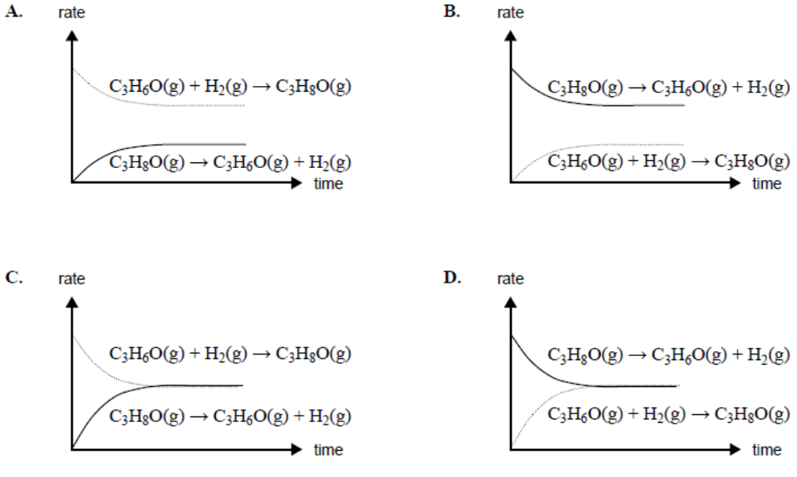
9. It is known that carbon monoxide reacts exothermically with hydrogen gas to form methanol at
400⁰C, in the presence of a catalyst.

CO _{(g)} + 2H₂ _{(g)} CH₃OH _{(g)} + heat

A mixture of carbon monoxide, hydrogen gas and methanol placed under conditions described above achieves equilibrium in a closed container. If the reaction temperature is changed to 450⁰C, which of the following statements is correct?

A. The reaction rates of both the forward and reverse reactions remain constant.
B. Total pressure within the container increases.
C. Rate of formation of hydrogen decreases while the rate of decomposition of methanol
increases.
D. The total number of molecules in the container decreases.
10. 1 mole of nitrogen gas and 3 moles of hydrogen gas were added to a rigid 1 L container at 298 K and left to react. At equilibrium it was found that the concentrations of nitrogen, hydrogen and ammonia were 0.116 mol L^{–1}, 0.348 mol L^{–1} and 1.768 mol L^{–1} and the pressure inside the container was 5.5 x 10³ kPa.

1 mole of hydrogen chloride gas was subsequently added to the container and the system was left to re-establish equilibrium (hydrogen chloride gas reacts with ammonia gas to produce solid ammonium chloride).

What are the concentrations (or range of concentrations) of nitrogen, hydrogen, ammonia and
hydrogen chloride once equilibrium has been reached for the second time?

Final concentration (mol L^{–1})
 | [N₂] | [H₂] | [NH₃] | [HCl]
A. | 0.116 | 0.348 | 0.768 | 0
B. | 0<[N₂]<0.116 | 0<[H₂]<0.348 | 0<[NH₃]<1.768 | 0
C. | 0.116 | 0.348 | 1.768 | 1
D. | 0<[N₂]<0.116 | 0<[H₂]<0.348 | 0<[NH₃]<1.768 | 1

End of Section One

Section Two: Short Answer Questions (15 marks)

11. One of the steps involved in the industrial preparation of sulfuric acid is the oxidation of sulfur dioxide to sulfur trioxide .

A. Write an equation to represent this reaction

1 mark

At room temperature 0.80 moles of SO₂ and 0.40 moles of O₂ were introduced into a sealed 10 L vessel and allowed to come to equilibrium.

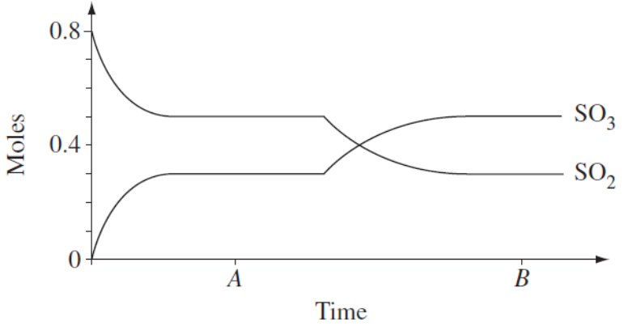
B. Write the equilibrium constant expression for the reaction

1 mark
C. Calculate the value for the equilibrium constant at time A.

2 marks
D. Explain why a new equilibrium position was established at time B.

1 mark
E. Give the name or formula for the catalyst that is most widely used for this reaction.

1 mark
The graph below shows the percentage conversion of sulfur dioxide to sulfur trioxide at equilibrium at a pressure of101.3 kPa and various temperatures.

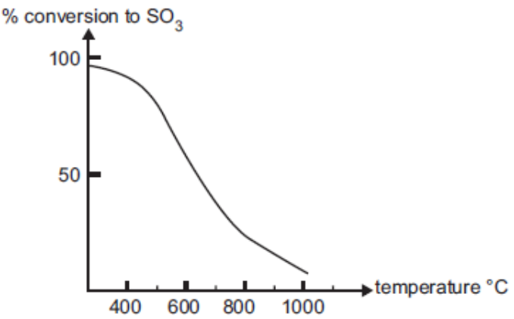

F. There is almost complete conversion of sulfur dioxide to sulfur trioxide at 300°C.
Explain why this reaction is performed at a higher temperature of approximately 450°C in industry.

1 mark
G. Explain why high pressures would increase the equilibrium yield of sulfur trioxide in this reaction.

1 mark
H. Explain why atmospheric pressure is usually used in industry, even though high pressures increase the equilibrium yield of sulfur trioxide in this reaction.

1 mark
A chemical reaction that involves sulfuric acid occurs in each of the following situations. Write a balanced chemical equation for each reaction.

I. Dilute sulfuric acid is added to sodium carbonate solution.

1 mark

J. Sulfur trioxide gas is bubbled through concentrated sulfuric acid.

1 mark

K. A piece of zinc metal is added to 6 M sulfuric acid. Zinc ions are formed as well as an oxide of sulfur in which sulfur exhibits an oxidation state of +4.

1mark

12. The graph shows the variation in concentration of reactant and products as a function of time for the following system.
COCl_{2(g)} Cl_{2(g)} + CO_{(g)} ; ΔH =+108 kJ

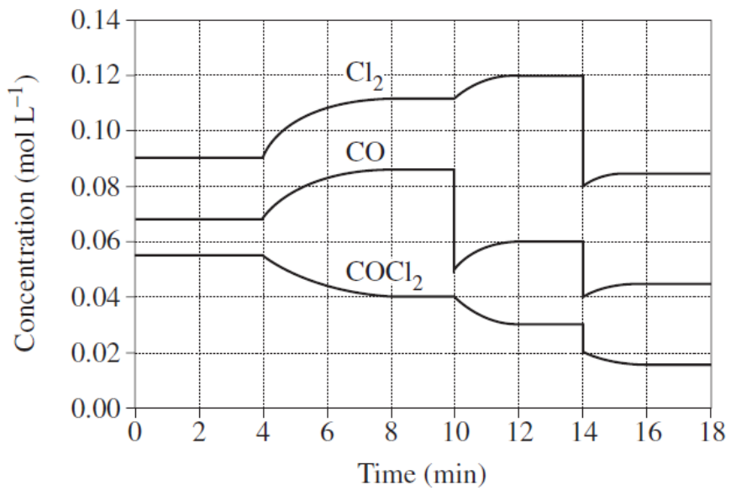

Identify each of the changes in conditions that have shaped the curves during the time the system was observed.

4 minute mark:

10 minute mark:

14 minute mark:

3 marks

Section Two: Extended Answer Questions (15 marks)
13. In the reaction between lead(II) nitrate and potassium iodide, lead(II) iodide is formed.

10 marks
A. Write a balanced equation using formula units for this reaction.

1 mark
B. What might you expect to observe in this reaction?

1 mark
2.00 g of lead nitrate is added to 3.00 g of potassium iodide,

C. Identify the limiting reagent.

3 marks
D. calculate the mass of lead(II) iodide formed

2 marks
E. calculate the mass of excess reactant remaining after the reaction.

3 marks

14. “Distinguish between rate and extent of a reaction and explain clearly the circumstances under which a rise in temperature may result in an increase in both for one reaction, and an increase in one and a decrease in the other in another reaction “.

5 marks

END OF TEST
UNIT3ACHE SOLUTIONS

RATES AND EQUILIBRIUM 2011: Answer all questions

Section One: MULTIPLE CHOICE QUESTIONS (10 marks)

1A | 2C | 3A | 4C | 5D | 6D | 7B | 8D | 9B | 10B

Section Two: Short Answer Questions (15 marks)

11.
A. 2SO_{2(g)} + O_{2(g)} 2SO_{3(g)} 1 mark

[SO₃]²
B. K_{eq} = ――――― 1 mark
[SO₂]² [O₂]

C. At time A
n(SO₃) = 0.3 mol; [SO₃] = 0.3/10 = 0.03 molL⁻¹
n(SO₂) = 0.5 mol; [SO₃] = 0.5/10 = 0.05 molL⁻¹
n(O₂)_{reacting} = ½ x n(SO₂)_{reacting} = ½ x (0.8 − 0.5) = ½ x 0.3 mol
= 0.15
n(O₂)_{at equilibrium} = 0.4 − 0.15 = 0.25; [O] = 0.25/10 = 0.025 molL⁻¹ 1 mark

K_{eq} = 0.3² ÷ (0.05² x 0.025) = 14.4 1 mark

D. O_{2(g)} was introduced into the system 1 mark
(Alternatively: the reaction is exothermic, therefore decreasing the temperature could account for the change because it favours the exothermic process)

E. V₂O₅; vanadium(V) oxide 1 mark

F. increase the rate of reaction (even though it reduces yield i.e. a compromise between rate and yield) 1 mark
G. Increasing the pressure shifts the position of equilibrium towards the product so as to partially counteract the imposed stress i.e. pushes the position of equilibrium in a direction so as to reduce pressure (3 moles → 2 moles)
1 mark
H. K_{eq} is large, therefore yield is high without increasing the pressure. 1 mark

I. H₂SO_{4(aq)} + Na₂CO_{3(aq)} = Na₂SO_{4(aq)} + CO_{2(g)} + H₂O_{(l)} 1 mark
J. SO_{3(g)} + H₂SO_{4(l)} = H₂S₂O_{7(l)} 1 mark

K. 2H₂SO_{4(aq)} + Zn_{(s)} = ZnSO_{4(aq)} + SO_{2(g)} + 2H₂O_{(l)} 1 mark
12.
4 minute mark: the temperature of the system was increased 1 mark
10 minute mark: CO removed from the system 1 mark
14 minute mark: the pressure of the system was decreased or volume of vessel increased. (This lead to a simultaneous decrease in the concentration of all 3 species)
1 mark
Section Three: Extended Answer Questions (15 marks)

13. A Pb(NO₃)₂ (aq) + 2KI(aq) → PbI₂(s) + 2KNO₃(aq)
OR Pb²⁺(aq) + 2I⁻(aq) → PbI₂(s) 1 mark

B A yellow ppte/solid forms when the 2 colourless solutions are added together or when the 2 white solids are shaken together 1 mark

C n(Pb(NO₃)₂) = m/M = 2/331.22 = 6.0383 x 10⁻³ or 0.006038
n(PbI₂) = (Pb(NO₃)₂) = 6.0383 x 10⁻³ or 0.006038 1 mark
n(KI) = m/M = 3/166 = 1.8072 x 10⁻² or 0.01807
n(PbI₂) = 2 x n(KI) = 2 x 1.8072 x 10⁻² = 3.611 x 10⁻² or 0.036144 1 mark
Since 0.006038 < 0.036144
Pb(NO₃)₂ is the limiting reagent as it produces the least amount of PbI₂ 1 mark

D from C. n(PbI₂) produced = n(Pb(NO₃)₂) reacted = 6.038 x 10⁻³ mol. 1 mark
m(PbI₂) = n x M = 6.03828 x 10⁻³ x 461 = 2.7836 g = 2.78 g PbI₂ produced
1 mark
E from the equation, n(KI)_{reacting} = 2 x n(Pb(NO₃)₂) = 2 x 6.0383 x 10⁻³
= 1.2076 x 10⁻² mol 1 mark
m(KI )_{reacting} = n x M = 1.2076 x 10⁻² x 166 = 2.0047 g 1 mark
m(KI)_{inxs} = m(KI)_{initial}− m(KI)_{reacting}
= 3 − 2.0047 = 0.9953 = 0.995 g KI 1 mark

14. Rate of reaction refers to the speed (rate) at which a reaction proceeds i.e. how fast is the reaction.
1 mark

Extent refers to the position of equilibrium i.e. how far towards completion does the reaction go or what is the yield.
1 mark

Temperature is the average E_{k} of the particles = ½mv². Increasing the temperature increases E_{k}, more particles will have E ≥ E_{a} (Energy of Activation). The velocity of the particles will also increase and there will be more collisions. Regardless of where the position of equilibrium lies, an increase in temperature will give an increased rate of reaction (both forward and reverse rates increasing).
1 mark

The equilibrium constant expression K_{eq} is temperature dependant. An increase in temperature favours the endothermic process. If the reaction as written is endothermic then the extent (yield) to which the reaction goes to completion will increase.

1 mark

On the other hand if the reaction as written is exothermic an increase in temperature favours the endothermic process pushing the position of equilibrium towards the reactants and the extent (yield) to which the reaction goes to completion (towards products) will decrease.

1 mark

